### Editing New Users

After adding a new user, the *Edit User* screen will appear. Fill in the appropriate text boxes in the *User Information* section. The *First Name*, *Last Name* and *Email Address* text boxes must be completed to create a new user. Once done, click on the **Save** button.

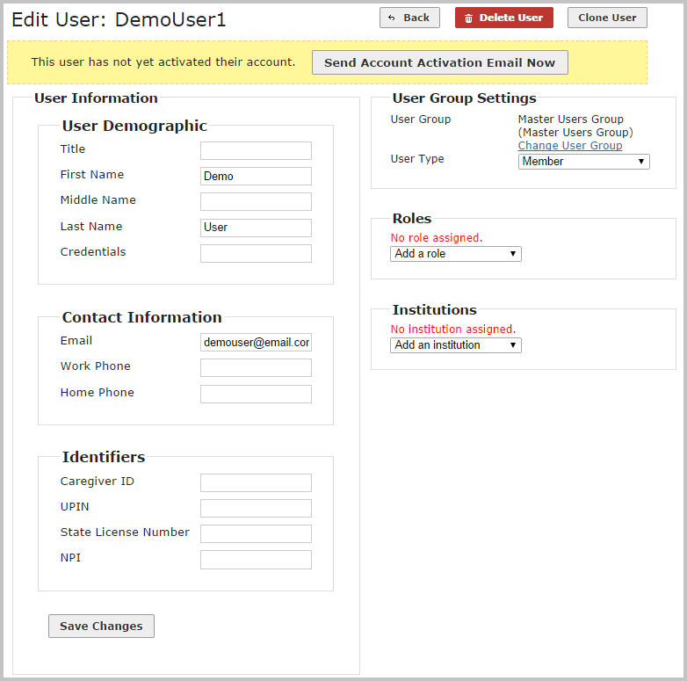

The **Send Account Activation Email Now** button at the top of the user account page allows the Administrator the option of immediately sending the account activation link or waiting until later (e.g., when creating multiple user accounts for a group go-live event).

If the account was created in error, click **Delete User** at any time during the process. The username will be made immediately available for use again in the system.

### Clone User

If the selection of user groups, roles, and institutions will be the same for multiple users, the **Clone User** button can be used to copy that part of a user’s configuration to another new user.

After making selections in the *User Group Settings*, *Roles*, and *Institutions* sections, click on the **Clone User** button. The *New User* screen will appear. Fill the new user’s *User Name*, *First Name*, *Last Name*, and *Email Address*, and then click **Add User**.

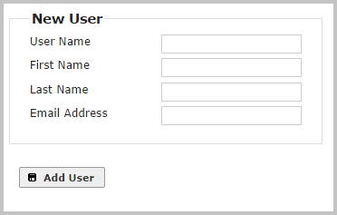

All of the user groups, roles, and institutions will be copied to the new user. Note that none of the demographic information will be copied, however.